1. **Why the RTS and CTS are not used in CSMA/CD?**

Because of hidden node problem in CSMA/CD -“occurs when a node is visible from a access point (AP), but not from other nodes communicating with that AP"

1. **Define routing?**

Routing is the process of selecting a path for traffic in a network, or between or across multiple networks.

1. **Explain with a diagram how the CSMA/CA uses different inter frame between the frames?**

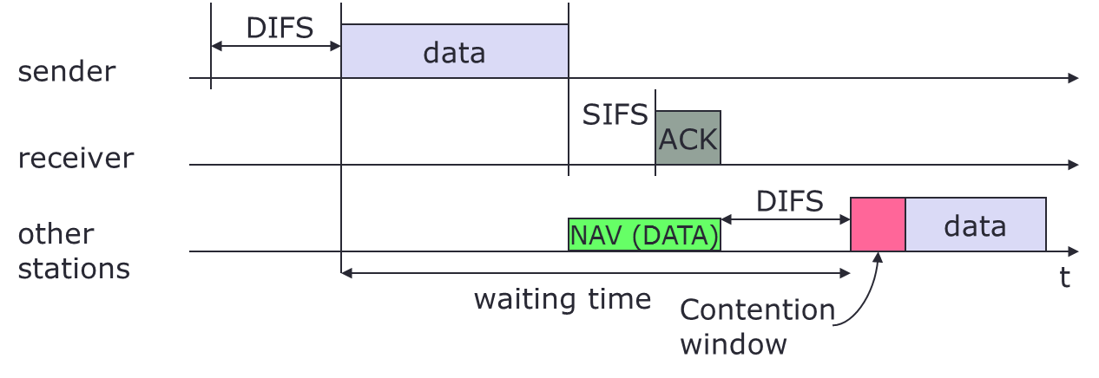

* + station has to wait for DIFS before sending data
  + receiver acknowledges at once (after waiting for SIFS) if the packet was received correctly (CRC)
  + automatic retransmission of data packets in case of transmission errors

1. **Explain bellman ford algorithm?**
   * + Dx(y) = estimate of least cost from x to y
     + Distance vector: Dx = [Dx(y): y є N ]
     + Node x knows cost to each neighbor v: c(x,v)
     + Node x maintains Dx = [Dx(y): y є N ]
     + Node x also maintains its neighbors’ distance vectors
     + For each neighbor v, x maintains Dv = [Dv(y): y є N ]
2. **What is the role of ARP table?**

We know that when two computers on the LAN want to communicate with each other the following will happen:

* + - An IP packet is created with a source and destination IP address carrying the data from an application.
    - The IP packet will be encapsulated in an Ethernet frame with a source and destination MAC address.

The sending computer will of course know its source MAC address but how does it know the destination MAC address? That’s where ARP comes into play.[1]

**briefly**: *To know the destination MAC address.*

1. **Explain the ARP protocol?**

* The ARP table is empty.
* The source will send an ARP Request - Since we don’t know the MAC address we will use the broadcast MAC address for the destination (FF:FF:FF:FF:FF:FF). This message will reach all computers in the network.
* The destination will reply with a message ARP Reply - the source can now add the MAC address to its ARP table and start forwarding data towards the destination.

1. **Define the network mask?**

* 32-bit number of contiguous 1’s followed by contiguous 0’s.
* To help to find the net ID and the host ID.

1. **What is the difference between slotted aloha and CSMA?**

Main difference between Aloha and CSMA is that *Aloha* protocol does not try to detect whether the channel is free before transmitting but the *CSMA* protocol verifies that the channel is free before transmitting data.[2]

1. [ARP (Address Resolution Protocol) explained](https://networklessons.com/cisco/ccna-routing-switching/arp-address-resolution-protocol-explained/)
2. [Difference Between CSMA and ALOHA](http://www.differencebetween.com/difference-between-csma-and-vs-aloha/)